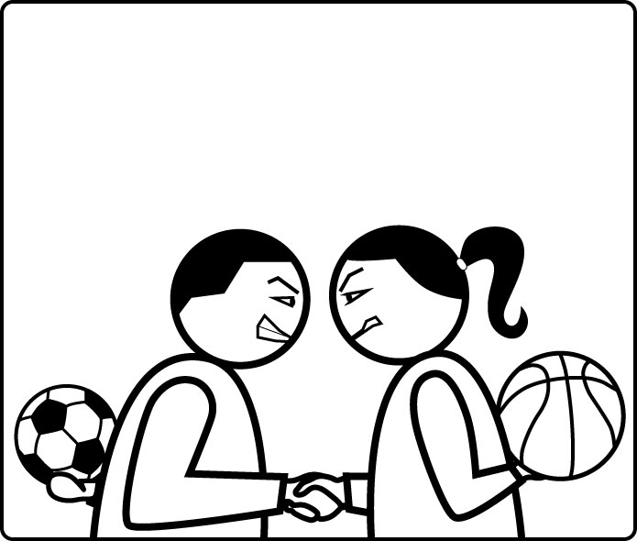

SOCIAL SPORTS
–
Play Your Friends !

Game Design Document

Design by Frédéric Fourcade
for Facebook, on Web and Mobile plateform

Introduction
Social Sports is a game where the user must select from players virtuallly generated from the user's facebook friends' list. These players are given sepcific role in a sport team, whiwh sport is selected from different ones available (Football at start, then Basketball, etc...). Once the team has been built, the player can challenge a random user or, better, one of his facebook friend. One of the game's main feature is that each player has a unique profile generated from its corresponding facebook profile, which means that two users having the same facebook friend will have the same corresponding friend in its pool of available players. This also means that making one of his player progress will also benefit to every facebook user having this same facebook friend.
Many other features shall be added in the future, but this core loop is the one that should be available in the First Playable version of the game.
This document will start by focusing on the features to be impolemented in the FPL, but then will be enhanced when the future version will start production.
To ease the reading of this document, some terms need to be defined :
- Manager : The role of the game user in game. It has some specific attributes and data, such as XP, level, coins, a pool of available (unlocked) and unavailable (locked) players.
- Player : A player is someone that the manager can put in his team, to play in the different matches the manager will play against other managers. A player has physical and mental attributes, that will be used to perform action in the field. Players can progress in their attributes, thus becoming better and better.
- User : Sometimes, we may refer to the user, which is the real person in front of his computer playing the game. It is used when speaking about some game design issue that relates directly to the usage of the application regardless of the game itself.
- Match : A match is what happens when one team challenges another team. It is the actual sport confrontation which is resolves by the match engine based on the team's players attributes, and finally gives a result. The term game is never used in this case to avoid confusion with the following term.
- Game : It is the application in itself, comprising all the screens, the features, the mechanices detailes in this document.

Table des matières :
Table des matières
1Introduction 2
2Table des matières : 3
3Player Profile 5
1.Player attributes 5
a)Physical attributes 5
b)Mental attributes 6
2.Player generation 7
a)Total amount of points to distibute 8
b)Individual attribute points distribution 8
3.Player profile screen 9
4Manager Profile 11
5Team Building Screen (Football) 12
6Challenge Screen 14
7Match Engine 16
1.Football 16
a)Overview 16
b)Mechanics 17
Movement 17
Offensive players 17
Defensive players 18
Positioning 18
Dribbling 18
Dribbling forward 18
Keeping the ball (Dribbling on the spot) 19
Passing the ball 19
Passing the ball (standard situation) 19
Passing the ball in the penalty area 19
Ball reception 20
Ball battle 20
Shooting 20
Shooting (close to the goal) 20
Shooting (from a distance) 20
Heading at goal 21
c)Influencial attributes 21
Team Cohesion 21
Determination 21
Lucidity 21
Condition 22
Luck 22
d)Summary 22
e)Player performance rating 23
f)Player progression 23
g)Football match engine simplification 23
8Football Result Screen 25
9Customizable Parameters 27
1.Player's attributes 27
2.Match Engine 27
3.Player performance 27
4.Player progression 27
5.Manager's rewards 27

Player Profile
The players in Social Sports are the main resource of the game. The core gameplay is based around their efficient use in building a team. The players have attributes which use is not obvious in the different sports available in the game. So the user must learn how to efficiently use them, by giving them the right role in the right sport. The attributes are specified below, then it will be explained how they are generated from the facebook profile of its corresponding user, and then the presentation screen will be detailed, with a mockup.

Player attributes
The players have 10 physical and 10 mental attributes. Each are detailed herebelow :

Physical attributes
- Acceleration : How quickly a player can reach his top speed. This is used when starting a move and is compared to the opponent's acceleration to check which one gets the advantage in the duel based on his acceleration value. For example, when an offensive player tries to pass through a defensive one, simply by using his going faster than him.
- Accuracy : The precision at realizing the intended complex move/action. Used in every action that is not natural, and therefore has been learned, trained, and asks for a precise immitation, such as every action aking a precise kick in the ball (pass, free-kick, shoot in Football), or precise launch of it (shoot, pass, dribble ni Basketball).
- Agility : How well a player can start, stop, change or move in different directions, on the field, in the air, with or without the ball. This is used to win a duel against a defensive opponent. For example, dribbling, avoiding defensor's block when shooting.
- Jumping : How high a player's head can reach when jumping, rather than how high he can actually leap. There is no such thing as height in the player profile, so the jump is really how high a player can reach. It is used when resolving a duel happening in the air (like a header, a goalkeeper save, a rebound, a block, etc...)
- Pace : How fast a player's top speed is. He will be slightly faster without the ball than with it. This is obviously used to calculate how quickly a player can reach the ball, or move with it, through the field. It can also make him harder to stop. But a player with high speed needs a high acceleration to make good use of it.
- Stamina : How much physical effort a player can endure during a match before his condition drops a percentage point. The higher a player's condition the better he will perform, therefore, the higher his stamina the longer he will perform well for. The condition is never displayed on screen, but it is used in every action the player makes (but can be compensated by his Determination and/or Work Rate).
- Strength : How well a player is able to exert his physical force on an opponent in a duel. It is used on a physical duel, for example, to win the ball for a header, take the good position under the basket, not to be too much impacted by the defense, etc...
- Hand Dexterity : How good a player is at performing actions with his hands. To simplify the gameplay, there no strong or weak hand, therefore it is really used when the hands are used to make the action, like goalkeeping and passing the ball with hands (Football), shoot, pass, dribble, layup, rebounds (Basketball).
- Foot Dexterity : How good a player is at performing actions with his feet. To simplify the gameplay, there no strong or weak foot, therefore it is really used when the feet are used to make the action, like dribbling, passing, kicking, tackling the ball (Football) or dribbling (Basketball)
- Head Dexterity : How good a player is at performing actions with his head. It is used mostly in Football to resolve actions done with the head. It could be used in new sports in the future (though I don't see which other sports use the head).

Mental attributes
- Anticipation : How well a player predicts the movements and actions of his teammates and opponents. Higher anticipation will enable a player to react more quickly to events, however, he will also need to be able to take up a good initial position. This is used, for example, for stealing the ball (by anticipating a pass or a dribble), blocking a shoot (goalkeeping in Football or block in Basketball), taking the ball after an ball bounce. Offensivelly, it can be used to escape a defender when off-the-ball, so the player can receive the ball in a good position.
- Composure : How well the player performs under pressure, particularly when facing heavy pressure from the opposition attack or a clear goal scoring opportunity. In particular, it affects a player's Anticipation, Intelligence and all actions in general. As for the Stamina and the player's condition, there is a invisible parameter, which is the Lucidity, and which affects the result of the actions in general when the match become more and more tightened. Therefore the players with highest Composure shall get an advantage over the lowest Composure players when the match gives more and more pressure.
- Concentration : How long during a match a player is able to stay focused and keep up his level of anticipation and decision making. Directly affects Anticipation and Intelligence. Like Composure, this attribute affects lucidity, but based on match duration rather then pressure.
- Creativity : How many opportunities a player can see when on the ball, or how likely is he to perform an unexpected action. However, the player will require other attributes in order to take advantage of the opportunity. It is used as a condition to perform a specific action, like passing the ball to a player that otherwise would seem not available, dribbling a defender that seems otherwise well-placed, avoiding a block, etc...
- Determination : How commited a player is to succeeding in every action they perform and in every match scenario. Like Luck, it can give a boost to the success of many actions, or compensate a bad player condition (cf. Stamina).
- Influence : How inspirational and motivational a player is to his teammates. It may affect other player's mental attributes. Influence, like Luck or Determination, can give a small boost, and gives it to the overall team (which is better), but only to Mental attributes (which is worse).
- Intelligence : How well a player chooses the best available option to take, as well as how to take it and when to take it, in order to benefit the team both on and off the ball. This attribute is used when many options are available to the player. So, for example, a good playmaker need to have good Creativity, Intelligence, Accuracy and Dexterity attributes.
- Luck : The luck of the player, which influences every action performed by the player. This attribute cannot improve while playing, but a player with less luck will progress slightly faster than a lucky one. However, this attribute can be changed by boosters.
- Positioning : How well a player positions himself in order to both deal defensively with potential attacking threats and offensively move without the ball to find space to receive the ball in a dangerous position. It is used mostly when not having the ball, to get the better opportunity to make a efficient action. For example, when the goalkeeper has anticipated a cross, he must use his positioning to go to the right position to catch the ball. The rebounder, when a shot is missed, must use his positioning to go to the better place to catch the ball.
- Work Rate : How mentally driven a player is to work hard throughout the match and in his carreer. It may impact some specific actions that usually require a great amount of work at training to be well performed on the field, like taking Free-kicks, Free-throws, long distance shots, dribbling, etc...

Player generation
When a user plays the game for the first time, all his facebook friends' profiles are gathered from his facebook profile. Then players are generated in the game from each of these facebook profiles (including himself). Since there are very few reliable data in the facebook profiles, there are not many of them we can use to generate a player profile in the game. To make the game balanced, each user starting values should have the same total. So, we have the facebook id (mainly), and most probably the birth date and the gender.

Total amount of points to distibute
Each attribute will have a value between 0 and 100, and a new player should start with an average value of 50. which make a total of 1000 points to distribute. We could give 500 points for physical attributes and 500 for mental attributes, but it would be better (add a little more “realism”), by using the gender to give more physical points to men, and the age to give more mental points to older people. So let's say, a man will have 550 points to distribute in his physical attributes and 450 points to his mental attributes. Women will have the opposite.
In the meantime, we will set the age of thirty as the pinnacle of the physical/mental balance, therefore every player younger will have more physical points, but les mental points, and older than 30 players will have more mental points and less physical. Players of 20 or below will have 100 points less than normal points in mental and 100 points more in physical. Each year between 20 and 30 will be make a 10 points difference. Above 30, every year will make a 5 points difference towards mental attributes, up until 50 years.
Finally, a 10% random will change these totals in one way or the other.
Therefore, a 20 years old male will have between 585/415 and 715/285 points in Physical/Mental attributes. A 20 years old female will have between 495/505 and 605/395 in Physical/Mental totals. A 30 years old male will have between 495/505 and 605/395. A 30 years old female will have between 505/495 and 395/605. A 50 years old male will have between 495/505 and 605/395. Anf finally, a 50 years old female will have between 415/585 and 285/715.

Individual attribute points distribution
Now that the total amount of points has been set to the mental and attributes categories, we can give points to the different attributes. The only data we can use for this is the facebook_id.
To do so, we must first randomly select the max and min value of each category (using the facebook_id as a seed). The min and max value can change depending on the total of points to allow to a category. The max value must be set between 10 and 30 points above the average number of points (with a limit of 90), and the min is set between 20 and 40 points below the average number of points (with a limit of 10).
Once these min and max values are set, a sequence of 10 random numbers is generated. The facebook_id is used as a seed. The max an min of these numbers are matched to the min and max values set previously. Then the second highest number is taken and a ratio is calculated from it and the range of random numbers, and then used to get a new value from the remaining total of points available. Then we do the same with the second lowest number, and so on, until the ten values of the category are set.
Finally, we shuffle the array of the ten attributes, and set each value to the attributes in their shuffled order to get the final attributes values. We do the same for the second category, and the player profile is set.
To conclude, we see that all the attributes generation is pseudo-randomly generated, based on data from the corresponding user profile. This way we can easily find the intial value of the player profile, for example to create an evolution graph/screen, showing the comparison between current player attributes and his initial ones.

Player profile screen
The player profile screen will present the corresponding user's facebook profile picture, his name, gender and birthdate, plus his attributes, and maybe some stats if any are added to the game in the future. The level of the player is actually the number of points earned since its creation.
There are two possibilities as for the display of the player profile :
- A screen : Some space shall remain available at the top and bottom of the screen to display the HUD and/or the navigation bar. It presents with the player's name, birthdate and gender, his attributes, and other data, like statistics.
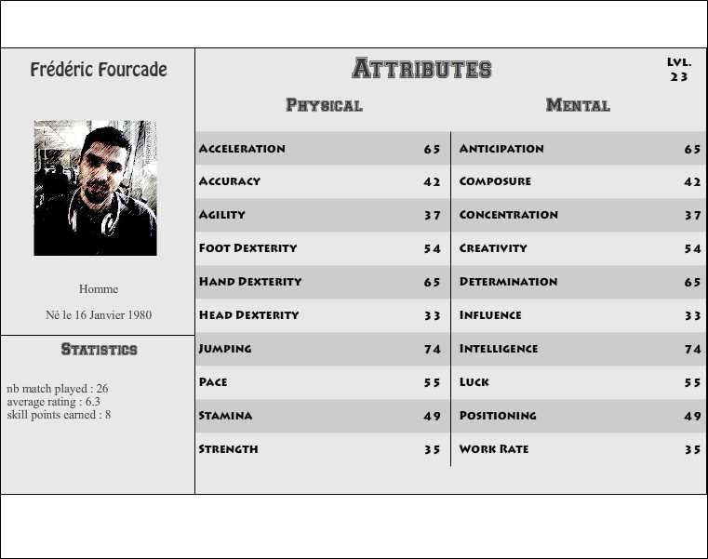
(The player screen. Space is left on top and bottom for the HUD and/or navigation bar)
- A popup : it can be displayed over any other screen, when clicking on a player name. It would help to get rid of the navigation bar, if we can keep the number of screen to a very few.
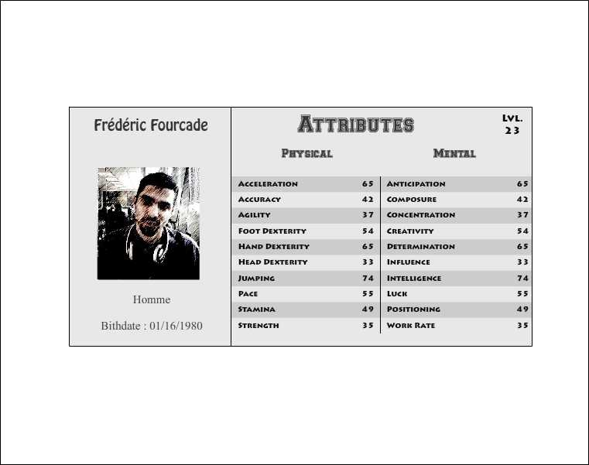
(The player popup. It takes significantly less space, and can be displayed anytime we need it)

Manager Profile
[ (N/A in V0) The manager profile is a tricky problem. Manager profile contains the number of XP, his level, his amount of coins and his pool of players. Since the players are already displayed (at least the unlocked ones) in the team building screen, there is no need to display them in the manager's screen (if there ever was one). Which would leave us with xp, level and coins, with XP and level being tightly linked together. So, two data could be handled in the hud actually. In order to take as few space as possible, we could put these two data in the top corners of the screen, so we don't have to use a full bar on top or bottom of the screen to display them.
In the future, if we want to display the manager's game statistics, we would have to create a specific screen for that, to go along with his office/achievements screen.
Visually it could look like this :
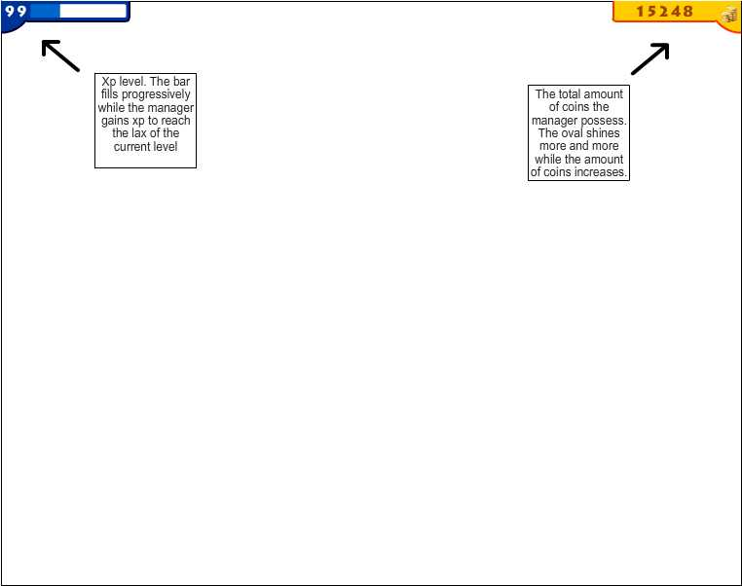
(The manager data displayed in the hud)

The V0 doesn't include Manager's data (like Xp and Coins), therefore the HUD will not appear until V0.9. ]

Team Building Screen (Football)
Here we are. This is the main and most important screen of the game. The user starts on this screen, and comes back to it after every match. Every data useful to play the core mechanic of the game should be available here.
Mainly, the screen is divided in two parts : The players list and the field. The players list lists all players in the manager's pool, and they can be filtered by unlocked or locked players. The list should display the picture, the name and the level of the player as well as an icon indicating that he has been put on the field, and most precisely, to which sport he has been assigned. The icon can also be used to indicate that the player is locked. The field is a representation of a specific sport field (the one selected by the user), with slots placed over it, corresponding to the most common placement of the corresponding sport (For example, a Football field would have a 4-4-2 representation).
Players can be dragged 'n dropped fromm the players list (on the left) to the field (on the right). It must be released above an existing role (represented by en empty profile slot). Dropping a player on an already set slot switches the players' role.
Clicking on a player's name or picture opens the player profile popup or screen (cf. Player Profile) to access the details of the player's attributes.
Two filter buttons at the top of the players list allows the player to switch display from unlocked to locked players and back.
There are also many buttons above the field part (one for each different available sport) to switch between the field representation of the different sports. One player cannot be part of two different teams.
Finally, this screen being the main screen of the game, all other screen should be accessible from there. That's why the bottom part of the screen (below the players list and field) will display some navigation buttons, like starting a challenge, and late, going to the Manager's office, checking statistics, displaying the activity screen, etc... Later, the size of the top part of the screen could be increased, to display the manager's booster belt, containing the permanent boosters selected by the user.
In order to see the players' attributes when trying to create the team, a small tooltip will appear on hovering over an unlocked player's name (or appear at the bottom of the screen on mobile devices).

Here is what the screen should look like :
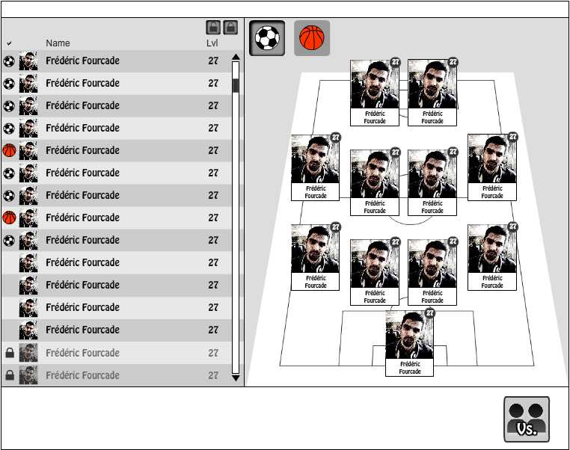
(The team building screen)
And here is the version with the Manager's HUD and a player popup above :
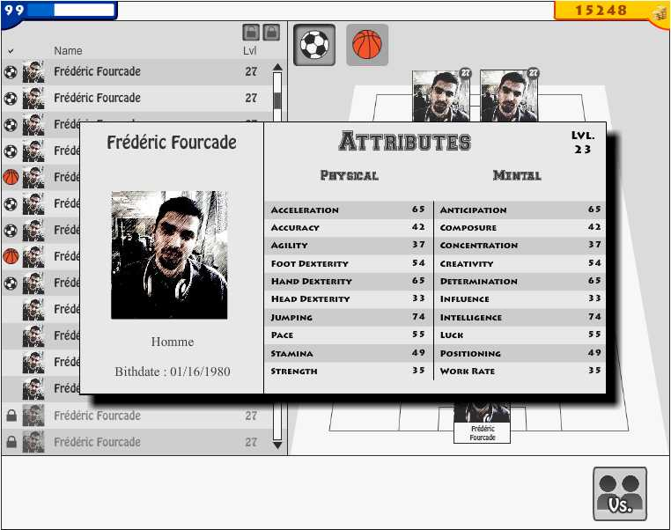
(The team building screen, with the HUD and a player popup)

Challenge Screen
The challenge screen opens when the player clicks on the “challenge button” in the Team Building Screen. This screen presents a list of friends to play against, and a “random opponent” button to get a random opponent through the world. The user can also challenge a non-playing friend, by clicking on the related button (labeled “challenge another friend”). The friend list displays every one of the user's facebook friends playing the game, with his picture, name, level and the average level of his team members. Below the friend list, a space is reserved to non playing friends of the user. These friends are picked randomly from the user's friend list. The space allowed is at least two friends, but, if the user as space left in the “playing friends” list, this space is then used to display more “non playing friends”.
Several buttons, corresponding to the available sports are displayed, with the last edited one (from the team building screen) selected by default. These buttons are used to choose the sport in which the two users will compete. Finally a “Start” button is displayed which starts the match resolution.
The selected opponent (either from the friends' list or via the “random opponent” button), is displayed at the bottom, next to the sport button, and the “Start” button. When the popup appears, and if no opponent has previously been selected (this is reseted when a match is performed), the application selects a friend opponent (or a random one if there are no friends playing the game), whose level and average team level is close to the user's. By clicking on the opponent's name, or on of the friend name, a popup should display his own team, but the players are not clickable (the user cannot see their player profile). But this screen gives an idea of the level of the different players in the team (which doesn't mean that they are used efficiently). [ (N/A in V0) Once an opponent is selected, a number should inform the user about the balance of power between the two, giving an idea of the difficulty of the challenge, but also giving the rewards modifier the user will have with this challenge (the harder the challenge, the better the rewards modifier, and vice-versa). If the chosen opponent is a non-playing friend, the level of difficulty is set to “?” (unknown), the bonus is set to +20% (a little bonus to push user at playing against non playing friends), and a texte explains that this user's profile will be automatically created with default player selection, so that the match can be played.]

Here is a mockup of the challenge popup, which will appear above the Team Building Screen :
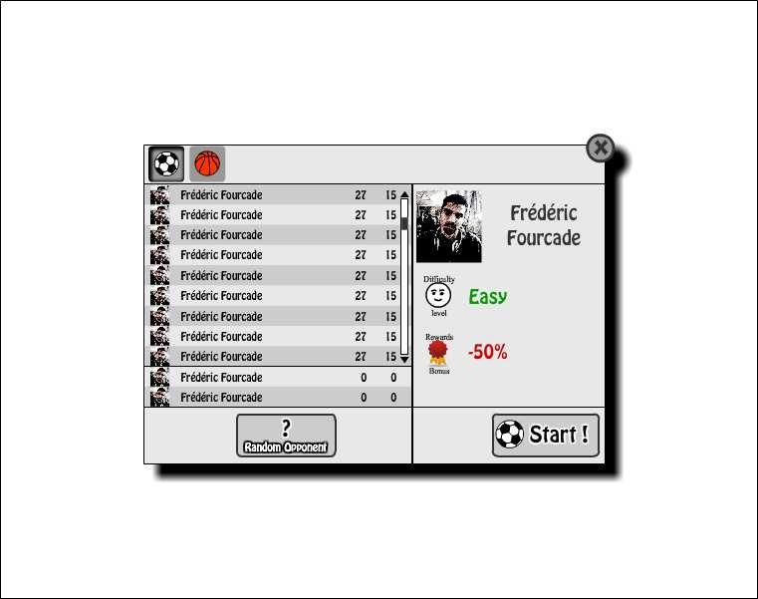
(The challenge popup)
And here is the version with the Team Building Screen behind, and the Manager's HUD above :
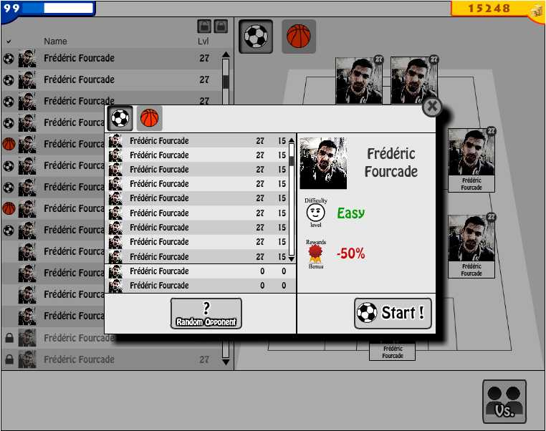
(The challenge popup, above the Team Building Screen)

Match Engine
Here the biggest part of the game, the match engine. Actually there will be as many sub-parts as there are available sports in the game. For now, only Football will be detailed, and others will come later.

Football
Before detailling the game engine itself, we will write an overview of the system, then it will be refined after having tested it in a prototype.

Overview
The engine is rather simple because it is the optimal proposition between realistic result and quick implementation. The field is divided in 20 tiles (5x4). There are a few numbers of tiles to make the simulation easier, but we could increase it in the future to make the simulation more complex, and therefore more interesting. No two players os the same team can be on the same tile, but two player from the two teams can be on the same tile. The Goalkeepers are not on any tile and can intervene in any of the two tiles in front of his goal (they are not counted as belonging to these tiles). Which leave the ten other players with 20 tiles to move in. A player can go across a tile where another teammate is to reach a farther tile.
The game is played on a turn basis. Each turn, the engine decide where the players move (if they move). A player in movement cannot make any other action, except receive/intercept the ball, if the ball is sent to or through this player's tile. If an offensive player does not move, he can choose to pass, shoot or keep the ball (wait). A non-moving defensive player in the same tile will automatically try to prevent the offensive player realizing his action.
Every “non-basic” decision or action is submited to a test (as in D&D). Most of the time, the test is actually a duel between two opponents. The test is done by using several of the player's attributes, in the following way :
- A random number between 0-99 is generated for every attribute involved in the test. The difference between the result and the player's attribute value represents the level of success for the use of this attribute (which is later used to calculate the player's performance, and his attribute's progression). The total of these results represents the level of success of the action.
- Various bonus/malus can be added to this result, depending on the context of the action (A defender is in the tile, a shot is made from distance, etc...)
- If the test is set against a fixed difficulty, the level of success of the action is compared to the expected result (the lower the expected result, the easier the difficulty to succees in the action).
- If the test is done against an opponent's action, the two level of success are compared, various bonus/malus included, and the one with the biggest level of success wins the duel.
The number of turn by half-time is yet to be defined/tested. Each time an attribute is used with success (the draw for the use of this skill is positive), the attribute progresses, and the overall performance of the player gets positive points (proportional to the success). When the player fails at using an attribute (the draw for its use is negative), the overall performance of the player gets negative points (proportional to the success), but the attribute does not regress.

Mechanics
As an overall rule, the defensive players always act after the offensive ones.

Movement
The first thing to do at the start of the turn is, for each player to decide to move or not (and where). Each player has a default start position, a default defensive position and a default offensive position. Depending on the game situation, The players will have to go to one of these default position:
- At the start of the half-time, after a goal-kick or a goal, the players are placed to their default start position (we don't care if at start of the half-time or after a goal the playres must be in their own half-court).
- When a team gets the ball, every player go to their offensive position.
- When a team loses the ball, every player go to their defensive position.
Once a player has reached his intended position, he has many options, depending if he is an offensive player or not, if he has the ball or not. When a player moves to a new tile, his pace will determine the number of turn to reach it. He must pass a Pace test for each tile he shall cross, with a malus for esch additional tile crossed after the first one (-30% if the player has the ball, -20% otherwise). If the test fails, the player stops his move for this turn on the failed tile, and will have to make the test again next turn, for the remaining tiles.

Offensive players
The moves available to an offensive player are the following :
- Basic moves : Offensive players will try to go closest to the goal. If attackers are offside, they will go backwards to their default position, and so on (they are actually doing a call for a pass). A defender with the ball will remain at his positon (and try to pass it), a midfielder with the ball will try to go forward with it (or pass the ball forward if he can't go forward), and a striker will try to go closer to the goal (or shoot at goal if he is close enough).
- Get more options (Creativity test) : After passing a Creativity test, more options are available to the player. A player without the ball can decide to go to another tile instead of remaining in his tile or moving forward. A player with the ball can pass or dribble with the ball, and move in any direction.
- Enhanced move for a player (Intelligence test) : After realizing an Intelligence test, the player evaluates the success rate of the different options basically available to him. By succeeding in the test, he can choose the one with the better success rate, otherwise he will randomly choose one of the available options (with a 2x factor for the basic move).
When offensive players have to move to a new tile, if they succeed in their Pace test, any static defensive player (if he is not occupied with another static offensive player in the same tile) can try to slow him. The offensive player must then succeed in a Acceleration*Anticipation*Agility*Pace vs. Acceleration*Strength*Work Rate*Anticipation), otherwise if will stop his move there for this turn, and try to complete it in the next turn.

Defensive players
- Basic moves : Defensive players will try to go closest to their own goal. Once they are at their defensive position, they will remain there. If an offensive player in the same tile moves towards the goal, the defender basically follows him.
- Enhanced move for a defensive player (Intelligence test) : If an offensive player in the same tile moves towards the goal, and the Defender passes an Intelligence test to check if the player will get offside, and if the ball handler has good chance of reaching him during his move. If the test is successful, the defensive player can try to follow him : he must then pass a Positioning*Anticipation*Acceleration against Acceleration*Positioning*Agility of the attacker.

Positioning
When two players are static in the same tile, they try to get the advantageous position over the other. It will decide the difficulty to pass the ball the offensive player. To do so, the offensive player passes a test of Agility*Strength*Intelligence vs. Anticipation*Strength*Work Rate. The result will be a modifier to the basic pass difficulty level.

Dribbling

Dribbling forward
When the player with the ball decides to move forward with the ball, and there is a static defensive player in a tile between his starting and finishing tile (include the starting tile), the offensive player must succeed in a test of Acceleration*Agility*Pace*Foot Dexterity*Creativity vs. Acceleration*Anticipation*Strength*Positioning*Work Rate.
If the test is a success, the offensive player keep on going forward, and will redo the test for each defensive player on his road (Actually he does that in parallel to the Pace test for moving forward.
If the test fails shortly, the player is stopped in his movement, and will have to resume it on the next turn.
If the test fails strongly, the defensive player wins the ball.

Keeping the ball (Dribbling on the spot)
When a player decides to keep the ball and not moving (to wait other players to take position for instance), and a static defensive player is on the same tile, the offensive player must pass test of Agility*Strength*Foot Dexterity*Creativity vs. Anticipation*Strength*Positioning*Work Rate.
If the test succeed the offensive player keeps the ball.
If the test fails, the defensive player gets the ball.

Passing the ball

Passing the ball (standard situation)
When the ball handler wants to make a pass to another player, the difficulty of the test depends on the situation :
- If the receiving player is alone and static, the basic difficulty is +50% (this is the easiest).
- If the receiving player is static, but with a moving defender, the basic difficulty is +30%.
- If the receiving player is alone and moving, the basic difficulty is +30%.
- If the receiving player is static, and with another static defender, the basic difficulty is the one calculated by the positioning duel (cf. Above).
- If the receiving player is in movement and with a static defender, the basic difficulty is -30% (- the result of an Antipation*Positioning test from the defender).
Once the basic difficulty is set, we must add the distance modifier : -20% by intermediate tile. The ball handler must then pass a successful test of Accuracy*Foot Dexterity against this difficulty.
If the test is a success, the pass is sent to the targeted player.
If the test fails, the ball gets to the static defender (if any), or to the following tile in the same direction, if there was no defender in the targeted tile.

Passing the ball in the penalty area
There is a special case when the pass is done in the penalty area, from a wing tile (it is actually a cross). The ball handler passes an Intelligence test to check which is the best capacity of the receiver between feet and head (use the average between attributes involved in shooting at goal and heading at goal). If the Intelligence test is a success, the passer passes using the best of the two options (on the ground, or in the air). If the test fails, there is 1 on 2 chance of making the passe on ground or in the air.
If the pass is an aerial cross, a new challenge is done to add the result to the difficulty defined by the positioning one test : Jumping*Strength*Anticipation*Positioning.

Ball reception
When a player receives the ball after a successful pass, and wants to get the control of it, he must pass a test of Accuracy*Agility*Foot Dexterity*Anticipation*Positioning with a bonus that is a success of the pass (a better pass makes the control easier).
If the test succeeds shortly, the player gets the ball.
If the test succeeds greatly, the defender (if any) will not be able to play in the next turn.
If the test fails shortly, and if a static defender is there, he gets the ball, otherwise the player keeps it.
If the test fails strongly, and a defender is there, he gets the ball, otherwise the ball goes to an adjacent tile.

Ball battle
In some rare occasions, the ball may be lost (meaning it doesn't belong to any team).
If the tile in which it's lost have only one player, this player gets the ball.
If the tile has two players, they must battle for the ball, which means passing a Anticipation*Work Rate*Acceleration challenge. The best gets the ball.
If the tile has no players, we wait for players to come to resolve this situation (restart the algorythm).

Shooting

Shooting (close to the goal)
If the attacking player decides to shoot at goal while he is in on of the tiles adjacent to the goal, he passes a test challenge of Accuracy*Foot Dexterity*Agility*Anticipation*Creativity vs. Anticipation*Positioning*Strength*Work Rate of the defender (if any) + Agility*Hand Dexterity*Jumping*Anticipation*Positioning of the goalkeeper.
If the test succeeds, then it's a GOAL !!!
If the test fails, the goalkeeper gets the ball (or it's a goalkick, it's the same result).
(later, we might add that a short fail results in a corner, but there are no corners to be implemented for now).

Shooting (from a distance)
When the player decides to shoot from one tile outside of the penalty area in front of the goal, the attcker must succeed in a test of Foot Dexterity*Strength*Anticipation*Creativity vs. Anticipation*Positioning*Strength*Work Rate of the defender (if any) + Agility*Hand Dexterity*Jumping*Anticipation*Positioning of the goalkeeper + distance modifer (-20% per intermediate tile).
If the test succeeds, then it's a GOAL !!!
If the test fails, the goalkeeper gets the ball (or it's a goalkick, it's the same result).
(later, we might add that a short fail results in a corner, but there are no corners to be implemented for now).

Heading at goal
When the attacker is in the penalty area and wants to try a header at goal, he must pass a test of Accuracy*Jumping*Head Dexterity*Anticipation*Strength vs. Agility*Hand Dexterity*Jumping*Anticipation*Positioning of the goalkeeper (ignore any defender, as it has already influenced the pass test).
If the test succeeds, then it's a GOAL !!!
If the test fails, the goalkeeper gets the ball (or it's a goalkick, it's the same result).
(later, we might add that a short fail results in a corner, but there are no corners to be implemented for now).

Influencial attributes
Several attributes of the players are not directly used to resolve the tests described above. Those have various impact on the other attributes and/or the various tests performed.

Team Cohesion
The player with the most Influence is (virtually) named captain of the team. The average influence value of team (including a 10x factor for the captain) is the value of the Team Cohesion attribute. This attribute impacts all teammates' mental attributes by taking its difference with 50, dividing it by 10, and adding this result to them. This value is calculated first so that all other mental attributes which changes the attributes of the players for the whole game can benefit (or not) to the players.

Determination
The Determination, like the Team Cohesion, changes the player's physical attibutes. This attribute impacts only the player's physical attributes by taking its difference with 50, dividing it by 10, and adding this result to them.

Lucidity
Lucidity is the mental awareness of the player through the game. It starts at 100%, and decrease through the match. It decreases at a regular rate defined by the player's concentration value (TBD by testing). This value is also influenced by a combination of Composure and match context (if the score is tight and the match well advanced, for example, a low Composure will drop the Lucidity, whereas a high Composure will make it slow the decrease rate).
The Lucidity value changes all other mental attributes, but is calculated in real-time (actually at the start of each turn).

Condition
Like Lucidity, the condition is the physical state of the the player. It changes in real-time the value of all the physical attributes. The condition starts at 100% and decreases depending on the Stamina value of the player.

Luck
The luck infleunces every action (every test) performed in the game. Its value divided by 10 is added to each individual attribute test result (or removed from the difficulty) to help the player succeed in it. That means that if the action tested needs 5 attributes, the luck is used 5 times, for each attribute. If the success is done thanks to the luck, the player won't be granted progression for this success.

Summary
To sum this all up, at the start of a match, the attributes of a player for this specific match are calculated following this order :
- Calculate the overall Team Cohesion value of the team (it is calculated only once).
- Add this Team Cohesion value to all mental attributes of the player.
- Calculate the Determination modifier of the player, and adds the result to all his physical attributes.
- Calculate the Lucidity decrease rate, based on the Concentration value.
- Calculate the condition decrease rate, based on the Stamina value.
- That leaves the player with the following attributes to play the game:
Physical | Mental | Hidden
Acceleration | Anticipation | Lucidity
Accuracy | Creativity | Lucidity decrease rate
Agility | Intelligence | Condition
Jumping | Positioning | Condition decrease rate
Pace | Work Rate
Strength
Hand Dexterity
Foot Dexterity | Composure
Head Dexterity

At the start of each new turn, the following values are recalculated :
- The Lucidity is decreased by its “decrease rate” modified by the Composure value of the player (its impact is yet to be defined).
- All the player's mental values are multiplied by this Lucidity value (in %)
- The Condition is decreased by its “decrease rate”.
- All the player's physical values are multiplied by the Condition value (in %)
Then, the match engine can start resolving the turn based on these values (cf. Mechanics).

Player performance rating
At the end of the game, a rating is given to each player for their overall performance in game. This rating is used by the user to see which player are at their right position, and who are not. This rating is set between 1 and 10.
It is calculated based on the results of the actions the player has performed during the game. The rating is actually the % of successful actions performed during the match.

Player progression
When the player succeeds in using an attribute (i.e. getting a random % below the attribute's value), then the player become better at using this attribute. As explained in the Luck part above, the progression is only granted if the success is not achieved thanks to the luck value.
This progression is very small (TBD with tests), and will consist of an invisible progression bar for this attribute (cf. The Elder's Scrolls : Skyrim skill progression system). When this progression bar is full, the attribute increases one point. The progression should be higher if the attribute has a low base value, than if it has a high one.
An attribute can never progress by more than 1 in a single game (although the algorythm should ensure that the progress rate is low enough to not allow that).

Football match engine simplification
Here is a simpler version of the match engine aimed at improve engine development speed.
Each turn, the ball handler gets 3 choices :
- one forward (one or two squares)
- one on the same line
- one backwards
The player first tries to send the ball forward, if it fails he tries the solution on the same line, and if it fails again, he tries the backward possibility.
When going forward, if the chosen tile is empty, it means that the closest player must try to reach this tile. If the closest player is the ball handler himself, he tries to dribble to this tile. In case of a failure, the attempt is cancelled, which means that an Intelligence test is made to check if the player has actually foreseen this failure and has decided to try another solution, which means that he keeps the ball a few seconds (while he is “thinking”), which asks to succeed in a ball keeping test. If both these tests succeed, the next attempt is made. When the third attempt (the backwards one) is also a failure, then the ball is lost to the closest player from the other team.

Football Result Screen
The result screen is displayed to the user when the match simulation is done, and the result has been sent back by the server to the client.
The result screen displays the result of the match (the score, with the scorers' name), and each player's performance rating. Some colors allow to easily see which ones have well performed (green) or badly (red). An arrow is displayed next to the players who have seen some of their attributes progress through the game. By clicking on these players, the Player popup appears, which contains the new player's attributes, with a little green “(+1)” next to the increased attribute. The list of players also list their position, so the user can quickly associate a player's performance with his position on the field.
At the bottom of the popup, a button “rematch” is displayed to replay the same game.
Next to it, the number of XP and coins gained through this game are displayed with a feedback animation where the coins go to the Manager HUD to increase the respective values (N/A in V0)
Finally At top right of the popup, a close button would allow the player to close the popup, and therefore going back to the Team building Screen.
Here is a mockup of the result popup:
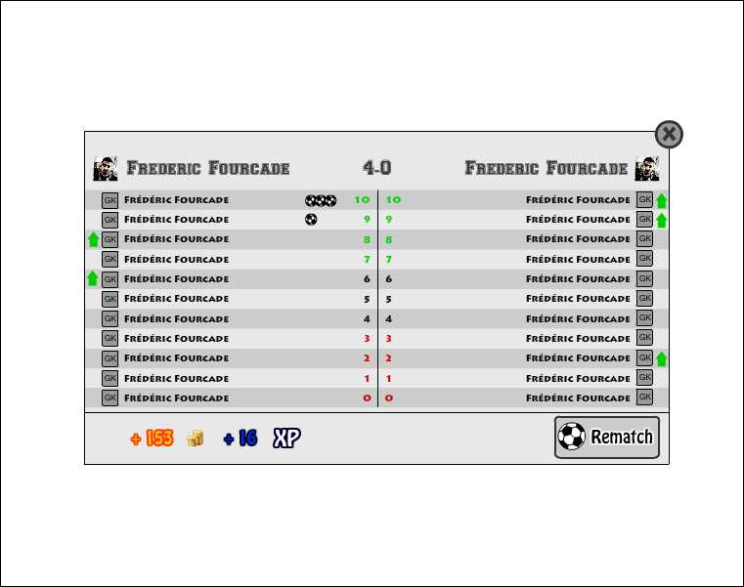
(The result popup)
And here is how it would look like above the Team Building Screen:
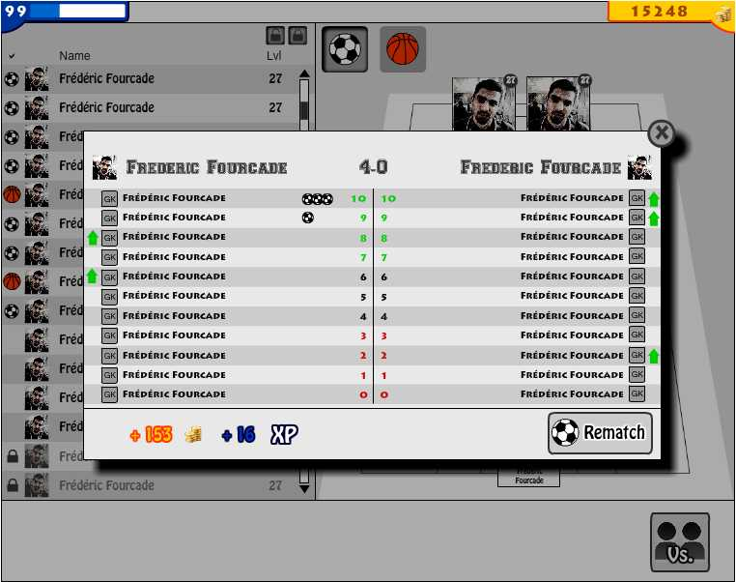
(The result popup, above the Team Building Screen)

Customizable Parameters
In order to be able to tweak the game quickly and easily, we need to have most of the game parameters customizable (in config file or backend). This chapter will list the parameters that need to be tweakable for the V0. For the purpose of this chapter, we will assume that this data will be listed in the DB.

Player's attributes
The name and description of the attributes have to be listed in a specific DB table. The progression rate of these attributes should also be listed there. The algorithm used to create the player profile (set attributes starting values) doesn't need to be set in a config file/table, as it will be isolated in a specific class.
The attributes need to have an integer id (autoIncrement from 0), which will be used to easily access a player's attribute's value from a standard Array to have quick access to them in the Match Engine.

Match Engine
The biggest part of the customizing will be done on the Match Engine.
Each action a player can perform consists in a group of different attributes a player must test to achieve a result higher than the difficulty level. This difficulty level can be a constant (so these constants should be customizable as well) or the result of an action performed by the opponent's player (this group of action shall be customizable too).

Player performance
As explain in the Player performance paragraph of the Match Engine chapter, the player's performance rating is the % of successful actions. But we could add a factor to the successes in order to give more accurate or realistic rating. And it could be different for each position, as we cannot know if some position will have a benefit compared to other ones.

Player progression
As for the player performance, the ratio of attribute progression should be customizable for each attribute, so that we can balance the progression of the different attributes.

Manager's rewards
The manager's rewards won't be available in the V0, but obviously, the ration between a win or a lose and the manager's level shall be customizable.

